

Asset Practice Answers: Science

**1. Answer the question based on the map given below:**

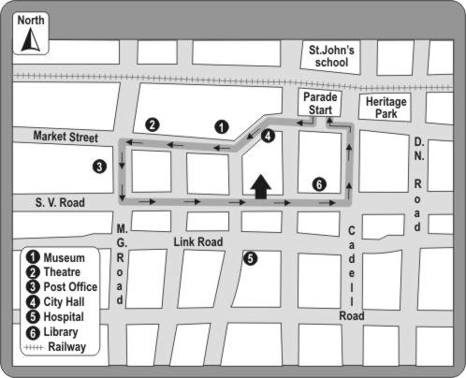

**In the map, the railway line lies to the of St. John's School. Which of these words can fill the blank above correctly?**

**A.** North **B. South C.** East **D.** West

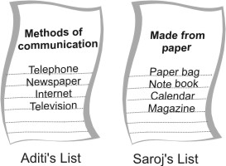**2. Aditi is making a list of methods of communication and Saroj is making a list of things made from paper.**

**Which of the following could be present in both the lists?**

**A.** A stamp

**B.** **An inland letter**

**C.** A mobile phone

**D.** A cardboard box

**3.**

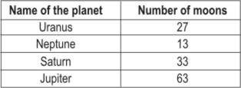

**The bar graph represents the information given in the table above. Choose the letter showing the bar that matches with Uranus.**

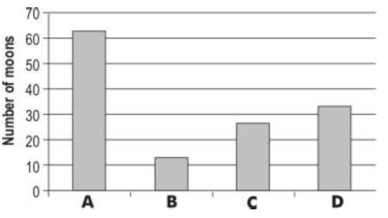

**Correct answer: C**

**4. A class had a torn umbrella. Which of the following materials that the teacher gave them, should they use to repair the umbrella?**

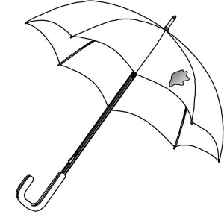

**A. A piece from an old raincoat.**

**B.** A piece of newspaper. **C.** A piece of cardboard.

**D.** A piece of silk cloth.

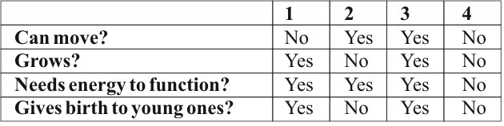**5. The table below shows the properties of four things which we will call 1, 2, 3 and 4. Study the table.**

**Which of them could be LIVING THINGS? A.** 3 and 4

**B. 1 and 3**

**C.** 2 and 3

**D.** 1 and 2

**6. In 1949, Lucky Lady II was the first airplane to go around the world non-stop. The pilots started their flight from a place called Texas in America and flew towards the East. They kept going in the East direction till they reached the same place from where they had started in America. The journey took around 4 days. Answer the following question based on this. People in America would have seen the plane travelling from West to East. In which direction would people in India have seen the plane travelling?**

**A. Coming from the West and going to the East**

**B.** Coming from the East and going to the West

**C.** Coming from the East and going back to the East

**D.** In any direction

**7. Materials have been grouped according to their properties in the table below.**

**Which letter in the table represents a piece of cardboard?**

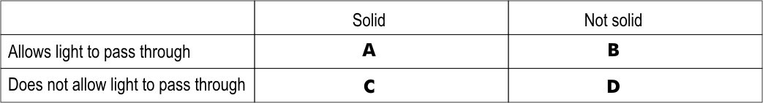

**Correct answer: C**

**8. Cooking gas leaks from a cylinder. How will it be known that gas is leaking?**

**A. From the special smell the gas has.**

**B.** From the colour of the gas.

**C.** From the colour of particles in it.

**D.** Drops of liquid will be seen near the gas cylinder.

**9. Why are buses more common than trains in hilly and mountainous areas?**

**A.** Because train engines are not strong enough to climb mountains.

**B.** Because mountainous soil cannot support the weight of the train.

**C.** Because people in the hills are poor, and cannot pay the train fare.

**D.** **Because** **laying railway tracks in mountains is difficult and costly.**

**10. Abhay has a mixture of rice, iron nails, wooden pieces and sand. As shown in the figure below, he brings an object close to the mixture.**

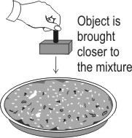

**When he does this, only one of the substances gets separated from the mixture. What object could**

**Abhay be holding?**

**A.** A vacuum cleaner **B. A strong magnet C.** A box with glue

**D.** A wet sponge

**11. How much would I have to walk to reach the restaurant from the tiger enclosure?**

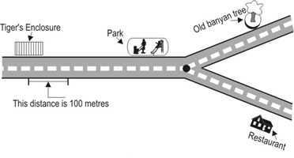

**A.** 200 metres

**B.** 400 metres

**C.** **600 metres**

**D.** 800 metres

**12. Jaya takes a glass of water, adds a spoon of sugar and then squeezes the juice of one lemon into it.**

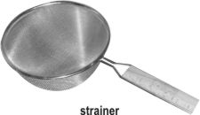**She stirs it well and then pours this through a strainer.**

**What will remain on the strainer? A.** Only water

**B.** Only lemon juice

**C. Only lemon seeds**

**D.** Lemon seeds and sugar



**Science**

1. B: Look at the map carefully. Where is St. John's School? It is at the Northernmost part of the map. You can see that the railway lines are slightly south of St. John's school. Thus, only option B is correct. St. John's school lies to the North of the railway lines, but the railway lines lie to the south of St. John's school. Hence, option A is incorrect.

2. B: A mobile phone and an inland letter are methods of communication, but a stamp and a cardboard box are not. Hence, options A and D are not correct. A mobile phone is not made from paper and so cannot be the right answer. The only thing that is made of paper and is also a method of communication is an inland letter. Hence, option B is the only correct answer.

3. C: Jupiter has 63 moons, which is shown by bar A, since it is the tallest bar. Now Saturn has almost half the number of moons as Jupiter - 33. So, it should be the bar which is half the size of A. Bar D is half the size of bar A. Uranus is

slightly less than Saturn - 27, so it should be slightly lower than bar D, which is bar C. Bar B represents Neptune - 13. We can check by reading the number of moons to the left of the graph also. Hence, option C is the correct answer.

4. A: If you want to repair an umbrella, you have to use something that will keep the water out. What happens to newspaper, cardboard and silk in water? They become wet. The paper and the cardboard may even tear. The silk cloth will not be

able to keep out water - try this at home. But, a raincoat is made of material that keeps water out. So, a piece from an old raincoat can be used to repair a torn umbrella. Hence, option A is the only correct answer.

5. B: All living things need energy to work and give young ones. These are two things that are common to all living

things.

Non-living things can move and some things like clouds can also grow, but that does not make them living. 'Thing 2' and

'Thing 4' do not give young ones and therefore cannot be living. Hence, options A, C and D cannot be correct. Only 1 and

3 need energy to work and give young ones as well. Hence, option B is the only correct answer.

6. A: If an object moves around the Earth in one direction, for example, East to West, then, on most part of the Earth, you will see the object moving from East to West in the sky. Try making a model of the Earth and the Lucky Lady II and see how it moves. It will not move in the opposite direction when you go to the other side of the Earth. Hence, option B is incorrect.

7. C: A piece of cardboard is a solid and it does not allow light to pass through. Which box in the table will show this? Only option C shows this. Option A shows something that allows light to pass through it, but cardboard does not. Hence, option A is incorrect.

8. A: Have you ever smelt a funny smell when the gas cylinder in your kitchen is changed? This is because something that has a strong smell is mixed into the gas. This way, when there is a gas leak, you will be able to smell it quickly. It is better to be warned by smell than to keep checking the cylinder for leaks. Also, we do not usually see drops of liquid near the gas cylinder, even when it's leaking - hence, option D is incorrect.

9. D: Train engines are very strong and can climb mountains easily if the tracks are placed properly. Mountainous soil can easily support the weight of a train, so options A and B are incorrect. You must have seen how the tracks go round up a mountain. It takes a lot of space and time to do this. Hence, laying these tracks is expensive and difficult. This is the main reason why buses are more common in hilly regions. Hence, option D is the correct answer.

10. B: If we bring a wet sponge close to this mixture, it will not pick up anything till we touch it to the mixture. Even if we do touch it to the mixture, it may pick up more than one substance. Hence, option D is incorrect. This is true for a vacuum cleaner as well as a box of glue. Hence, options A and C are incorrect. A magnet will only pick up the iron nails. Hence, option B is the only correct answer.

11. C: Look at the small bar marked in the map that shows how much 100 metres is on the map. How many of those bars will fit between the Tiger's enclosure to the Restaurants? If you check carefully, around 6 of those bars will fit. Now, we know that each bar is around 100 metres on the map. So, 6 bars will mean around 600 metres on the map. Thus, only option C is correct.

12. C: When you add lemon juice and sugar to water and stir it properly, the juice and the sugar get mixed into the water. You will not be able to see them after some time. But, lemon seeds do not get mixed in water. Hence, when you pour the lemon juice with the seeds through a strainer, only the seeds will be left on the strainer. Hence, only option C is correct.